Pathfinder for Cantkier’s STEM project

- Check Destiny to see what we have in the library. When you do a search, you will see other resources below the books we have in the library. Check these Databases or Open Educational Resources for additional information. HELPFUL HINT: Check a book’s index or Table of Contents to zero in on the info you need.
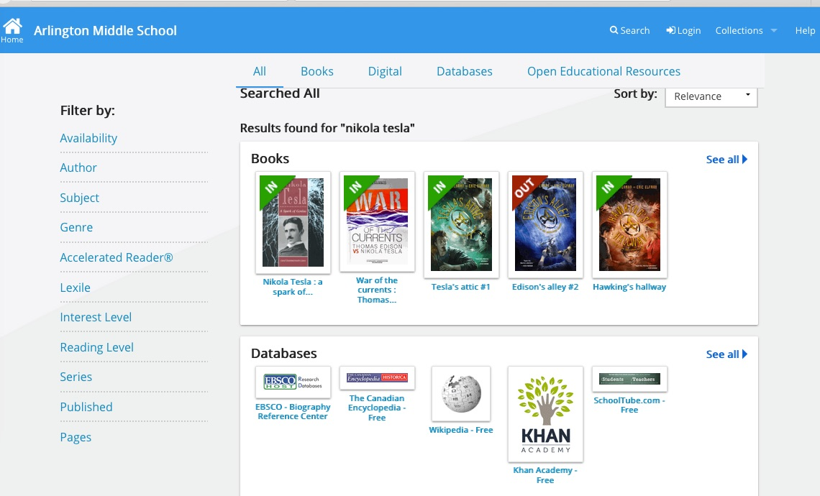

- AMS subscribes to a biography database. You can access it from my web pages>Students>Reliable Info Sources>Biography. It is the very first tile on the top left. The user name is “arlingtonmiddle” and the password is “bobcats”. Each article also includes a citation.

- Britannica is a good source for general info. Often the article will have extra materials that you can access from the column on the left. Be sure to check out “Primary Sources” and “The Web’s Best Sites.” See picture below. Citations are given for the articles. NOTE: If you access Britannica outside AMS, you may be asked for a user name & password. Both are “arlington”.

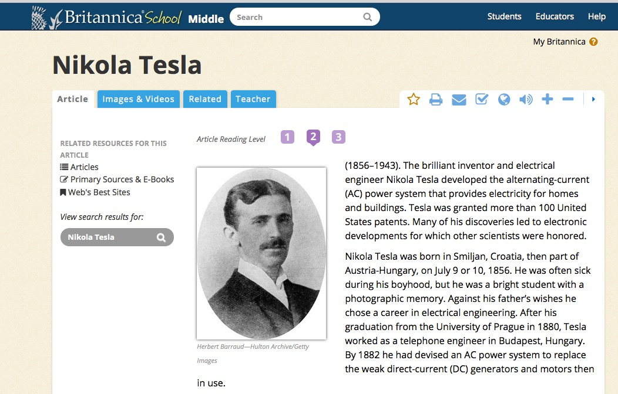
- Britannica is also one of the BEST sites for images. You can click on the Images and Video tab within the article. Or you can go directly to this address for even more pictures: http://quest.eb.com These pictures are copyright friendly for school assignments. You can click on “Download” to download the picture to your desktop or create a Britannica account and save it there.

- For this or other assignments that require biographical information, check out my Biography Symbaloo webmix. On my webpage, choose Students>Reliable Info Sources>Biography.

